Place your logo, contact information, and other necessary information here.

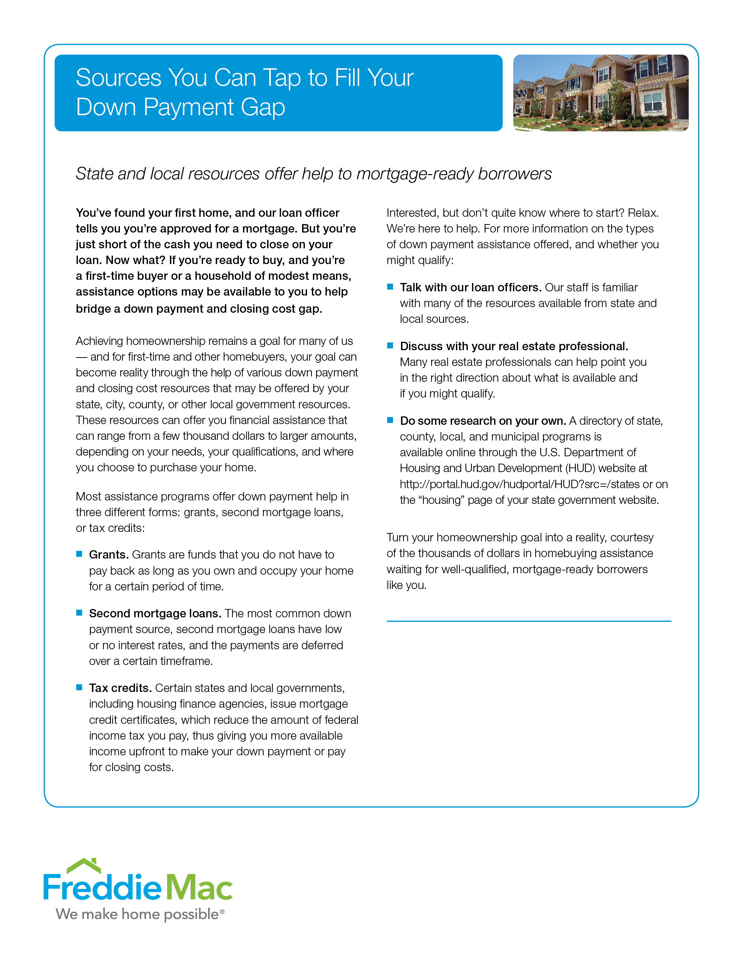
The designated customization area is defined by the blue horizontal line above, the right and bottom edges of the curved outer blue rectangle and the flush-left side of the right-hand column. Do not place any graphics or text outside of this space.

