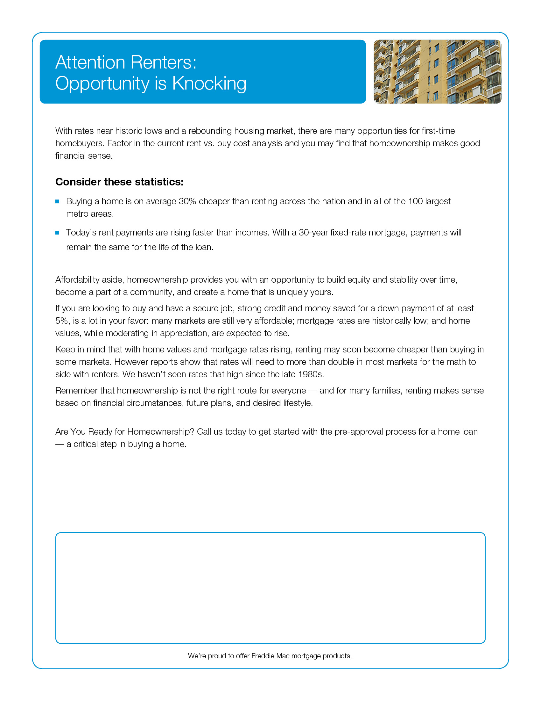

Place your logo, contact information, and any other necessary information here.
(Center vertically and horizontally in white box)

